

C PROJECT REPORT ON
CONTACT BOOK

SUBMITTED TO
The Technical Department
KG College of Arts and Science

SUBMITTED BY
Student Name | Roll No. | Course & Batch
PREMKUMAR S | 25BIT136 | B.SC IT ‘B’(2025-2028)
PREM S B | 25BIT137 | B.SC IT ‘B’(2025-2028)
RAKSHAN D | 25BIT138 | B.SC IT ‘B’(2025-2028)
RAMITA V | 25BIT139 | B.SC IT ‘B’(2025-2028)
RITHISH M S | 25BIT140 | B.SC IT ‘B’(2025-2028)

Academic Year: 2025 – 2026
Semester: I

DECLARATION
We hereby declare that the project entitled “CONTACT BOOK” submitted in partial fulfilment of the requirements for the course C PROGRAMMING is a record of our original work carried out under the guidance of VASANTH M,, Technical Trainer, Technical Department, KGiSL MicroCollege.
We further declare that this project has not been submitted previously, either in part or in full, for the award of any degree, diploma, or other similar title, at this or any other institution.
We have acknowledged all sources of information used in this project wherever applicable.
Student Name | Roll No. | Course & Batch | Signature
PREMKUMAR S | 25BIT136 | B.SC IT ‘B’(2025-2028)
PREM S B | 25BIT137 | B.SC IT ‘B’(2025-2028)
RAKSHAN D | 25BIT138 | B.SC IT ‘B’(2025-2028)
RAMITA V | 25BIT139 | B.SC IT ‘B’(2025-2028)
RITHISH M S | 25BIT140 | B.SC IT ‘B’(2025-2028)

Place: COIMBATORE
Date: ______________

CERTIFICATE
This is to certify that the project entitled “CONTACT BOOK” is a bona fide work carried out by the following students of B.SC IT(2025-2028) ,,B.SC INFORMATION TECHNOLOGY ,, KG College of Arts & Science, in partial fulfilment of the requirements for the course CONTACT BOOK”.
This project has been completed under my supervision and guidance during the academic period [MARCH 2026].
It is further certified that this project is the original work of the students and has not been previously submitted for the award of any degree, diploma, or certificate at this or any other institution.
Project Team:
S. No. | Name | Roll Number
1. | PREMKUMAR S | 25BIT136
2. | PREM S B | 25BIT137
3. | RAKSHAN D | 25BIT138
4. | RAMITA V | 25BIT139
5. | RITHISH M S | 25BIT140

Guide: Head of the Department
(Technical Trainer, KGM) (Technical Head, KGM)

______________________ _______________________

Place:
Date:

ABSTRACT
The project “Contact Book Management System” is developed in the C programming language to efficiently manage and organize personal contact information. The main objective of this project is to simplify and streamline the process of storing, retrieving, and maintaining contact details in a structured manner.
The system allows users to add new contacts by entering details such as name, phone number, and address. It also provides options to view all saved contacts, search for a specific contact using keywords, update existing contact details, and delete unwanted records. The application uses file handling techniques to store the data permanently, ensuring that the contact information can be accessed and modified whenever required.
This project demonstrates the effective use of arrays, structures, functions, and file handling in C to create a well-organized and efficient application. The design focuses on simplicity, ease of use, and accuracy in managing contact records, making it suitable for personal or small-scale use.
Through this project, practical concepts of structured programming, control flow, modular design, and data management have been implemented successfully. It enhances programming logic and problem-solving skills while providing real-world experience in developing basic data management systems.

TABLE OF CONTENTS
S. No. | Topics | Page. No.
1 | Introduction
1.1 | Objective
1.2 | Overview
1.3 | Features
2 | Program Analysis
2.1 | Problem Definition
2.2 | Project Overview
2.3 | Scopes and Limitations
3 | System Design
3.1 | Modules
4 | Methodology
4.1 | Problem Analysis
4.2 | System Design
4.3 | Program Development
4.4 | Testing and Validation
4.5 | Result and Documentation
4.6 | Algorithm
4.7 | Flowchart
5 | Source Code
6 | Input and Output Screens
7 | Discussion and Conclusion
7.1 | Discussion
7.2 | Conclusion
8 | References

- INTRODUCTION

1.1 Objective
To design and develop a Contact Book Management System using the C programming language.
To simplify the process of storing, retrieving, and managing contact details efficiently.
To demonstrate structured programming concepts — arrays, loops, conditional statements, functions, and file handling.
1.2 Overview
This system allows users (cashiers or waiters) to:
- View all saved contacts
- Add new contacts with details like name, phone number, and address.
- Search for specific contacts using name or number.
- Accepting Update existing contact details.
- Accepting Delete unwanted contacts from the system.
1.3 Features
- Interactive menu-driven interface.
- Contact details stored using structures.
- Supports adding, editing, deleting, and searching contacts.
- Displays all contacts in a clear format.
- Uses file handling to save and retrieve data permanently.
- Easy to use and suitable for beginners.

- PROGRAM ANALYSIS

2.1 Problem Definition
Managing contacts manually can be difficult, especially when the number of contacts increases. There is a need for a simple program to efficiently handle contact details, including:
- Storing names and phone numbers.
- Searching contacts quickly in a case-insensitive manner.
- Updating existing contact details easily.
- Displaying all contacts in an organized format.
- Validating phone numbers to ensure correctness.

2.2 Project Overview
Aspect | Description
Language Used | C
Compiler | GCC / Dev-C++ / Turbo C++
Concepts Used | Structures, Arrays, Functions, Loops, Conditional Statements, String Handling
I/O Type | Console-based
Storage Type | In-memory (No file handling used)

2.3 Scopes and Limitations
Scope:
- Suitable for personal use or basic contact management.
- No graphical user interfaceSupports adding, searching, updating, listing, and resetting contacts.
- No Includes validation for phone numbers and duplicate name checking.
- No Can be extended to include file handling for permanent storage.
Limitations:
- Works only in text (console) mode.
- No graphical user interface.
- Data is not stored permanently (lost after program exit).Works only in text (console) mode.
- Limited to a maximum of 100 contacts.
- Stores only name and phone number (no additional details like email or address).

- SYSTEM DESIGN
3.1 Modules
The Contact Book Management System is divided into multiple functional modules, each responsible for a specific operation. These modules work together to manage contact details efficiently and provide a simple user experience.

Module Name | Description
Menu Display Module | This module displays the complete list of food items and beverages available in the restaurant, along with their corresponding item numbers and prices. It allows the customer or cashier to view all options before placing an order.
Order Input Module | This module accepts the customer’s choice of items and their quantities. It validates each input, ensuring that the selected item number exists and that the entered quantity is a valid number. It stores each order line for further processing.
Billing Calculation Module | This module computes the subtotal by multiplying the price and quantity for each ordered item. It then calculates the applicable GST (5%) and the final grand total. It ensures accuracy in the billing process by performing all mathematical computations automatically.
Bill Printing Module | This module generates a detailed bill format that includes the item name, quantity, price, subtotal, tax, and final total. It presents the bill in a neatly formatted tabular display for the customer.
File Storage Module (Optional) | This module stores each generated bill into a text file (bill.txt) for future record keeping. It appends new transactions to the file, acting as a simple sales record system for the restaurant.
Exit/Termination Module | This module safely terminates the program after completing all billing operations. It displays a closing message (“Thank you! Visit Again!”) to indicate the end of the transaction.
Module Interaction Overview
- Add Contact → stores new contact details.
- Search Contact → finds a contact by name.
- Update Contact → modifies existing contact details.
- List Contacts → displays all contacts.
- Reset Module → clears all contacts.
- Exit Module → ends the program safely.

- METHODOLOGY
The development of the Contact Book Management System follows a structured methodology that includes five main stages: Problem Analysis, System Design, Program Development, Testing & Validation, and Results & Documentation.
4.1. Problem Analysis
In this stage, the process of managing contacts manually was studied and analyzed.
The main problems identified were difficulty in searching contacts, duplication of entries, lack of organization, and chances of data loss.
Based on this, clear objectives were defined — such as adding new contacts, searching contacts quickly, updating details, and displaying all records in an organized format.
The problem was divided into smaller tasks to make the program simple, modular, and efficient.
4.2. System Design
During the design phase, the logical structure of the system was created.
The main components identified were:
1.Add Contact
2.SearchContact
3.UpdateContact
4.ListContact
5.Reset
Data structures like and structures (struct Contact) were designed to store contact details such as name and phone number.
Algorithms were also prepared to define the step-by-step process before coding.
4.3. Program Development

This is the implementation phase where the design is converted into code using the C programming language.
The program was developed using modular programming concepts by dividing it into functions such as adding, searching, updating, and listing contacts.
Control structures like loops, if-else conditions, and switch statements were used. String handling functions and validation logic were also implemented to ensure correct input.

4.4. Testing and Validation
After coding, each module was tested individually to ensure correctness.
Test cases were created for different situations such as:
Validcontactent
Invalidphonenumber
Searchingnon-existingcontact
Updating existing contact
The program was tested thoroughly and validated to ensure error-free performance.

4.5. Result and Documentation
Finally, the program produced the desired result — an efficient and user-friendly contact management system.
It successfully allows users to store, search, update, and display contacts.
The system ensures accuracy and ease of use.
Proper documentation was prepared, including algorithm, module descriptions, sample outputs, and conclusion, making the project easy to understand and extend in the future.
4.6. Algorithm
An algorithm is a step-by-step procedure used to solve a problem or perform a task.
For the Contact Book management System , the algorithm defines how contacts are added, searched, updated, and displayed.
Purpose of the Algorithm
The main purpose of using an algorithm in this project is to:
- Define the logical flow of contact operations.
- Ensure accuracy in storing and retrieving data.
- Provide a clear structure before coding.
- Make the system easy to understand and modify.
Algorithm in the Project
The algorithm performs the following steps:
1.Start the program and display the title.
2.Display menu options (Add, Search, Update, List, Reset, Exit).
3.Accept user choice.
4.If user selects Add Contact:
Read name and phone number.
Validate input and check duplicates.
Store contact in array.
5.If user selects Search Contact:
Read name.
Search contact (case-insensitive).
Display result.
6.If user selects Update Contact:
Read name.
Find contact and update phone number.
7.If user selects List Contact :
Display all stored contacts.
8.If user selects Reset:
Clear all contacts.
9.If user select Exit :
Terminate program.
10.End program.

Importance of Algorithm in the Project
- Helps in converting contact management logic into program steps.
- Ensures systematic flow and correctness.
- Acts as a blueprint for coding and debugging.
- Improves clarity, modularity, and efficiency of the program.
4.7. Flowchart
The flowchart represents the logical flow of the Contact Book Management System . It visually outlines the sequence of operations — from displaying menu options to managing contacts — ensuring clarity in how data is processed at each stage of the program.
Explanation of Flow
- Start – Program begins execution.
- Display Menu – Shows options like Add, Search, Update, List, Reset, and Exit.
- Take Order Count – The user selects an operation from the menu
- Process Each Order –
Add Contacts
Accept name and phone number.Validate input (check empty name,valid phone).
Check duplicate contact.
Store contact in array.
Search Contact: Accept name.
Perform case-insensitive search.
Display result if found.
Update Contact
Accept name.
Search contact.
Update phone number after validation.
List Contacts
Display all contacts in tabular format.
Reset Contacts
Clear all stored contacts.
Exit
Display exit message and terminate program.
- Repeat Process – Return to menu after operation (except Exit).
- End–Program stops execution

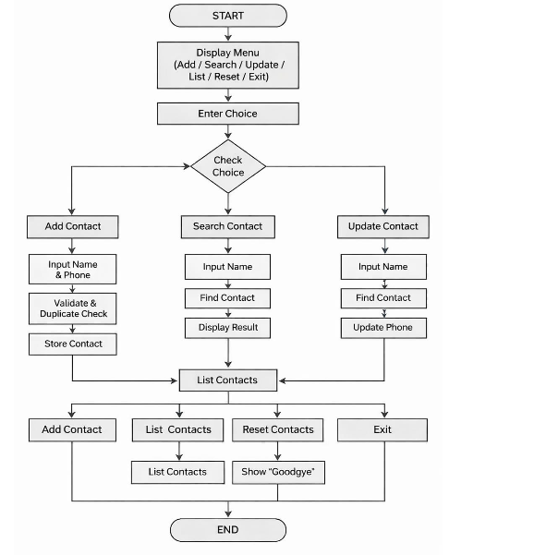

- SOURCE CODE

#include <stdio.h>
#include <string.h>
#include <ctype.h>
#define MAX_CONTACTS 100
#define MAX_NAME_LEN 40
#define MAX_PHONE_LEN 15
// ===== Structure =====
typedef struct {
char name[MAX_NAME_LEN + 1];
char phone[MAX_PHONE_LEN + 1];
} Contact;
Contact contacts[MAX_CONTACTS];
int count = 0;
// ===== Utility: Convert string to lowercase =====
void toLowerCase(char *dest, const char *src) {
for (int i = 0; src[i]; i++) {
dest[i] = (char)tolower((unsigned char)src[i]);
}
dest[strlen(src)] = '\0';
}
// ===== Validate phone =====
int isValidPhone(const char *phone) {
int len = (int)strlen(phone);
if (len < 5 || len > 15) return 0;
for (int i = 0; i < len; i++) {
if (!isdigit((unsigned char)phone[i])) return 0;
}
return 1;
}
// ===== Find contact by name (case-insensitive) =====
int findContactIndex(const char *name) {
char lowerInput[MAX_NAME_LEN + 1], lowerStored[MAX_NAME_LEN + 1];
toLowerCase(lowerInput, name);
for (int i = 0; i < count; i++) {
toLowerCase(lowerStored, contacts[i].name);
if (strcmp(lowerInput, lowerStored) == 0) return i;
}
return -1;
}
// ===== Add Contact =====
void addContact() {
if (count >= MAX_CONTACTS) {
printf("[ERROR] Contact book full!\n");
return;
}
char name[MAX_NAME_LEN + 2], phone[MAX_PHONE_LEN + 2];
printf("Name (≤40): ");
if (!fgets(name, sizeof(name), stdin)) return;
name[strcspn(name, "\n")] = '\0';
if (strlen(name) == 0) {
printf("[ERROR] Name cannot be empty.\n");
return;
}
if (findContactIndex(name) != -1) {
printf("[ERROR] Duplicate name.\n");
return;
}
printf("Phone (5-15 digits): ");
if (!fgets(phone, sizeof(phone), stdin)) return;
phone[strcspn(phone, "\n")] = '\0';
if (!isValidPhone(phone)) {
printf("[ERROR] Invalid phone number.\n");
return;
}
strcpy(contacts[count].name, name);
strcpy(contacts[count].phone, phone);
count++;
printf("[OK] Added.\n");
}
// ===== Search Contact =====
void searchContact() {
char name[MAX_NAME_LEN + 2];
printf("Search name: ");
if (!fgets(name, sizeof(name), stdin)) return;
name[strcspn(name, "\n")] = '\0';
int idx = findContactIndex(name);
if (idx == -1) {
printf("Not found.\n");
} else {
printf("Found: %s - %s\n", contacts[idx].name, contacts[idx].phone);
}
}
// ===== Update Contact =====
void updateContact() {
char name[MAX_NAME_LEN + 2];
printf("Update name: ");
if (!fgets(name, sizeof(name), stdin)) return;
name[strcspn(name, "\n")] = '\0';
int idx = findContactIndex(name);
if (idx == -1) {
printf("[ERROR] Contact not found.\n");
return;
}
printf("Current phone: %s\n", contacts[idx].phone);
char newPhone[MAX_PHONE_LEN + 2];
printf("New phone (5-15 digits): ");
if (!fgets(newPhone, sizeof(newPhone), stdin)) return;
newPhone[strcspn(newPhone, "\n")] = '\0';
if (!isValidPhone(newPhone)) {
printf("[ERROR] Invalid phone number.\n");
return;
}
strcpy(contacts[idx].phone, newPhone);
printf("[OK] Updated.\n");
}
// ===== List All Contacts =====
void listContacts() {
if (count == 0) {
printf("[INFO] No contacts to display.\n");
return;
}
printf("# %-40s %-15s\n", "Name", "Phone");
for (int i = 0; i < count; i++) {
printf("%-3d %-40s %-15s\n", i + 1, contacts[i].name, contacts[i].phone);
}
}
// ===== Reset =====
void resetContacts() {
count = 0;
printf("[OK] All contacts cleared.\n");
}
// ===== Main Menu =====
int main() {
int choice = 0;
char line[10];
printf("=== CONTACT BOOK (No Files) ===\n");
while (1) {
printf("\n1) Add 2) Search 3) Update 4) List 5) Reset 6) Exit\n");
printf("Choice: ");
if (!fgets(line, sizeof(line), stdin)) break;
if (sscanf(line, "%d", &choice) != 1) continue;
switch (choice) {
case 1: addContact(); break;
case 2: searchContact(); break;
case 3: updateContact(); break;
case 4: listContacts(); break;
case 5: resetContacts(); break;
case 6: printf("Goodbye!\n"); return 0;
default: printf("Invalid choice.\n");
}
}
return 0;
}

SOURCE CODE EXPLANATION:
1) Headers & Macros
#include <string.h>
#include <ctype.h>
• stdio.h → used for input/output functions like printf, fgets.
• string.h → used for string operations like strlen, strcmp, strcpy.
• ctype.h → used for character checking like tolower, isdigit.
#define MAX_CONTACTS 100
#define MAX_NAME_LEN 40
#define MAX_PHONE_LEN 15
• Defines maximum limits for contacts, name length, and phone number length.

2) Data Model (Structure)
typedef struct {
char name[MAX_NAME_LEN + 1];
char phone[MAX_PHONE_LEN + 1];
} Contact;
• Contact structure stores:
◦ name → contact name
◦ phone → phone number
Contact contacts[MAX_CONTACTS];
int count = 0;
• contacts[] → array to store multiple contacts
• count → keeps track of total contacts stored

3) Utility Function – Convert to Lowercase
void toLowerCase(char *dest, const char *src)
• Converts a string into lowercase.
• Used for case-insensitive searching (e.g., “Ram” = “ram”).

4) Phone Number Validation
int isValidPhone(const char *phone)
• Checks:
◦ Length must be between 5 to 15 digits
◦ All characters must be digits
• Returns:
◦ 1 → valid
◦ 0 → invalid

5) Search Function (Find Contact)
int findContactIndex(const char *name)
• Converts both input name and stored names to lowercase
• Compares using strcmp()
• Returns:
◦ Index if found
◦ -1 if not found

6) Add Contact Module
void addContact()
Steps:
• Check if contact list is full
• Input name and phone
• Validate:
◦ Name should not be empty
◦ Phone must be valid
◦ No duplicate name allowed
• Store data in array
• Increment count

7) Search Contact Module
void searchContact()
Steps:
• Input name
• Search using findContactIndex()
• If found → display name and phone
• Else → show “Not found”

8) Update Contact Module
void updateContact()
Steps:
• Input name
• Find contact
• If found:
◦ Show current phone
◦ Input new phone
◦ Validate phone
◦ Update value
• Else → show error

9) List Contacts Module
void listContacts()
• Displays all contacts in tabular format
• Shows:
◦ Serial number
◦ Name
◦ Phone number

10) Reset Module
void resetContacts()
• Sets count = 0
• Deletes all contacts from memory

11) Main Function (Menu Driven Program)
int main()
• Displays menu:
1) Add
2) Search
3) Update
4) List
5) Reset
6) Exit
• Takes user choice
• Uses switch case to call functions

12) Exit Condition
case 6: printf("Goodbye!\n"); return 0;
• Ends the program safely

Control Flow Summary
Display menu options
1.User enters choice
2.Perform selected operation:
Add → store contact
Search → find contact
Update → modify contact
List → display all
Reset → clear all
3.Repeat until user selects Exit
4.Program terminates

- INPUT AND OUTPUT SCREENS

Output Screen:
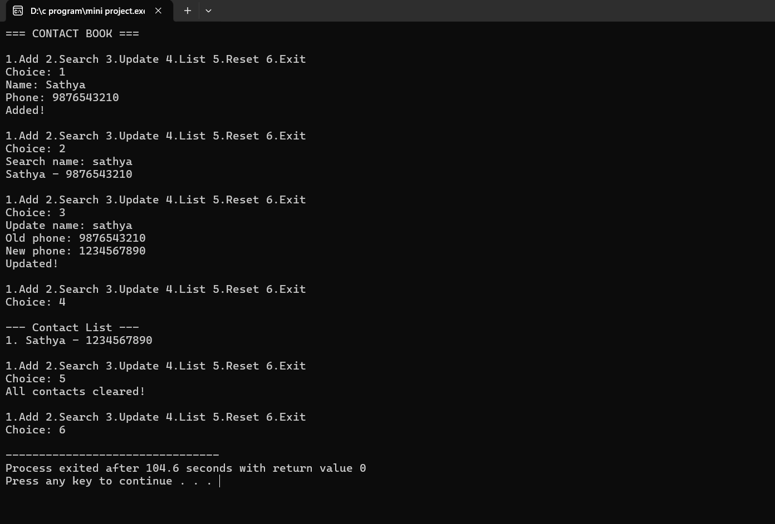
- DISCUSSION & CONCLUSION

7.1 Discussion
This project successfully implements a Contact Book Management System by:
- Using structured programming and modular design.
- Applying arrays, structures, and functions for efficient data handling.

This project successfully implements a Contact Book Management System by:
- Using structured programming and modular design.
- Applying arrays, structures, and functions for efficient data handling.
- Implementing validation techniques for phone numbers and duplicate entries.
Providing useful operations like adding, searching, updating, listing, and resetting contacts.
The system is simple, efficient, and user-friendly, making it suitable for personal or basic contact management.

7.2 Conclusion
The project meets its intended objectives:
- Provides a simple and effective way to manage contacts.
- Demonstrates real-world application of C programming concepts like structures, arrays, and control statements.
- Ensures organized storage and quick retrieval of contact information.
The system can be further enhanced by adding features like file storage, email fields, sorting contacts, and graphical user interface (GUI).

- REFERENCES

1. Kernighan & Ritchie, The C Programming Language, Prentice Hall, 1988.
2.TutorialsPoint – C Programming
3. GeeksforGeeks – Restaurant Billing in C
4. Dev-C++ User Manual

